Varun Rajareddy – 1995327

Harish Singampalli -1995431

Sushumna Kaja -1995429

Vijay Kumar Burugu - 1993961

Sanath Vennapureddy - 1994900

Drive:

<https://drive.google.com/drive/folders/108SlfmAetsOPb3L2qujg7EGxSOE9KqxU?usp=sharing>

Git Hub:

<https://github.com/varun-rajareddy/AlphaCo.git>

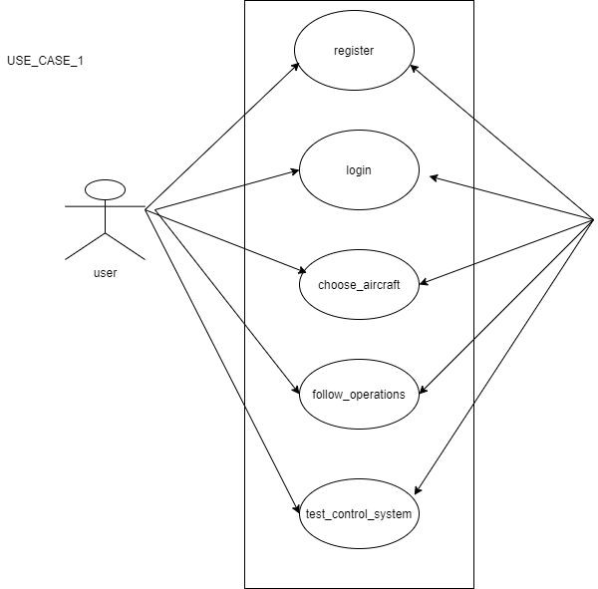

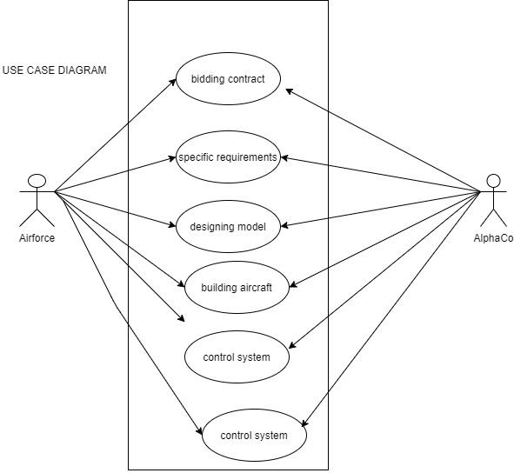

CLASS DIAGRAM

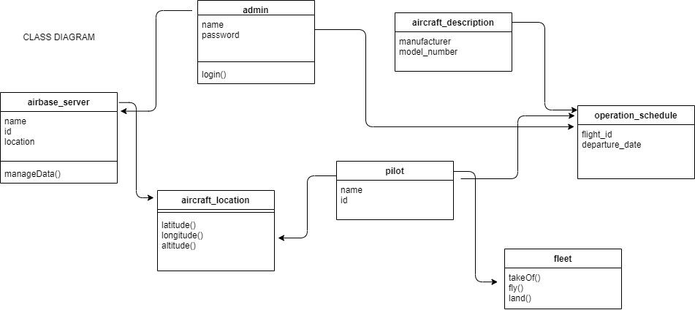

SEQUENCE DIAGRAM

